Getting to KUAS

Kaohsiung University of Applied Sciences (KUAS) is located in the Sanmin District of Kaohsiung city. The university can be reached by either way as below:

Chien Kung Campus
Start point | Arrive | Bus | Time
Kaohsiung airport | KUAS  (Chien Kung Campus) | 214－37  14－37  15－37 | 80 minutes  80 minutes  60 minutes

Start point | Arrive | Bus | Time
Kaohsiung train station | KUAS  (Chien Kung Campus) | 53  30 | 40 minutes  35 minutes

Start point | Arrive | Bus | Time
MRT-  Houjing Station | KUAS  (Chien Kung Campus) | 29  30 | 25 minutes

Chien Kung Campus
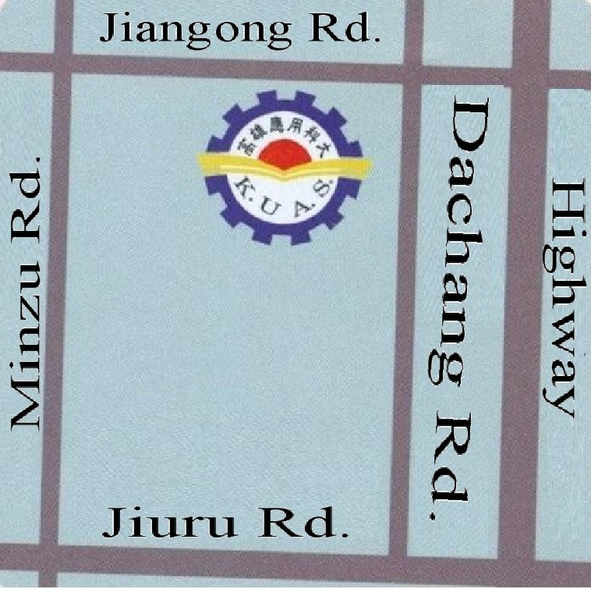

KUAS Map

Chien Kung Campus

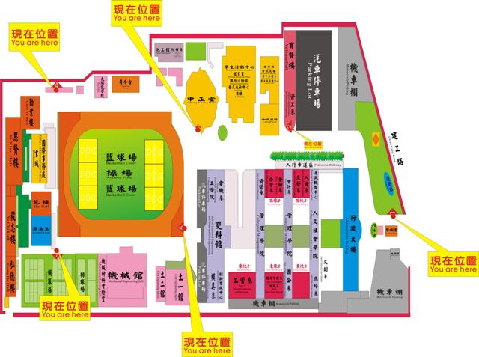
OIA

